Nepal College of Information Technology
Assessment Spring 2012
Program : BE CE/ELX Time : 3 hrs
Semester : spring (II) FM : 100
Subject : Applied Mechanics PM : 50

- Candidates are requested to give their answer as far as practicable in their own words.
- The figure in the margin indicates the full marks
- Attempt ALL question

1. a) State the general equation of equilibrium. What do you mean by free body diagram and what are its uses? (5)
b) Three cables are used to support a container as shown. Determine the angle formed by cable AC and AD. (10)

x
y
450 mm
650 mm
700 mm
z
D
C
B
A
O
600 mm
1125 mm

2. a) Two identical rollers each of weight 50N rest on an inclined plane which makes an angle 60⁰ with the vertical wall. Find reactions at all points of contact supports assuming all surfaces to be smooth. (10)

B

A
A

30⁰

b) Define Couple. What are the characteristics of couple? State and prove varignon theorem. (5)

3. a) Locate the centroid given figure (7)
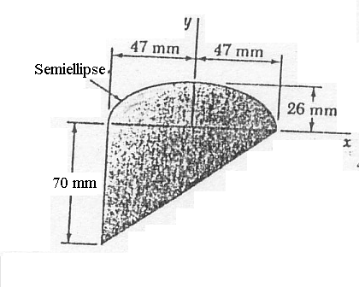
b) State and prove parallel axis theorem. Locate the centroid of the composite line shown. (8)
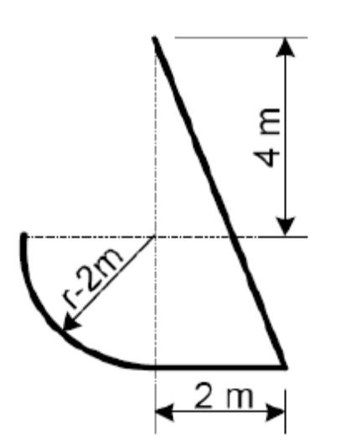

OR

Locate the centroid of the given bounded area shown
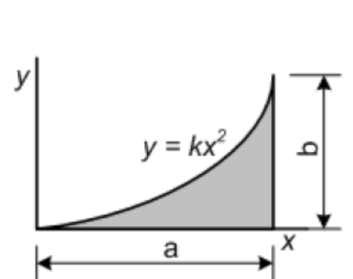

4. Draw shear force and bending moment diagram of given beam. 15)

4 m
2 m
2 m
10 KN/m
15 KN

5. Analysis the given truss by method of joints. (15)
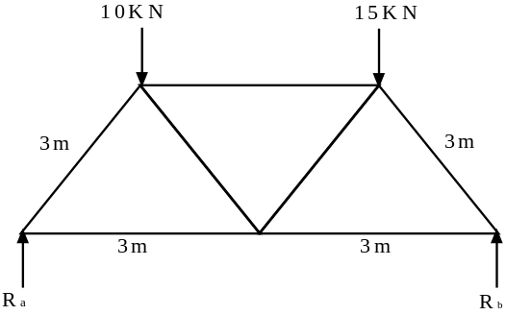

6. a) The motion of the particle is defined by the relation x = 4t³-15t²-16t+12 where x and t are expressed in meters and seconds respectively. Determine (i) when the velocity is zero (ii) the position and total distance travelled when the acceleration is zero. (8)
b) Define the rectilinear motion of the particles. Derive the expression for the motion of the particles when acceleration of the particles is the given function of time. (7)
7. Write Short Notes on (any two) 5x2=10
a) Relation between loading, shear force and bending moment
b) Co-ordinate System
c) Graphical Representation of rectilinear motion.
d) Dependent Motion

